1.passport system

Usecase diagram

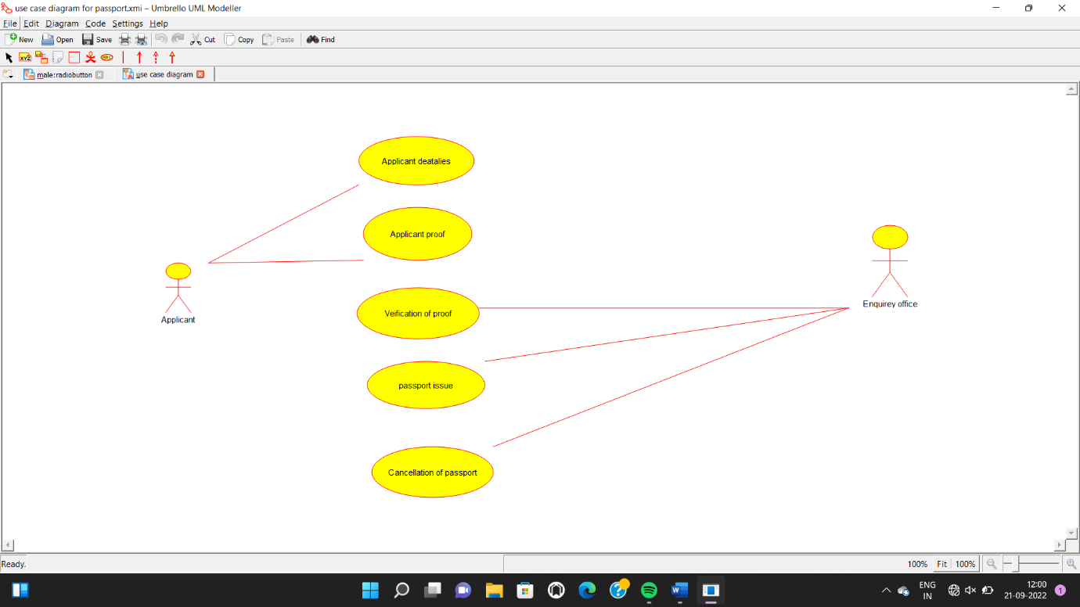

Class diagram

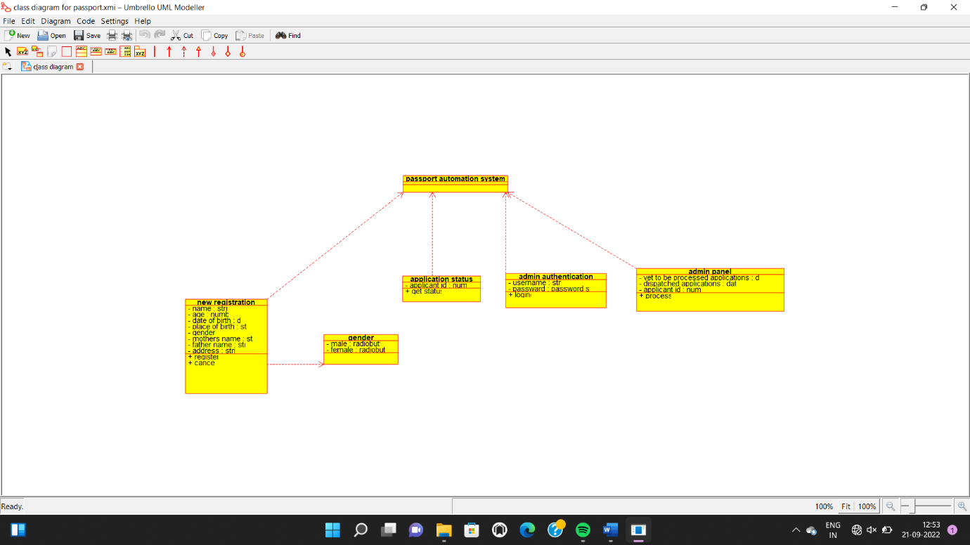

Source code

"new_registration.h"#include

// Constructors/Destructors

//

new_registration::new_registration () {

initAttributes();

}

new_registration::~new_registration () { }

//

// Methods

//

// Accessor methods

//

// Other methods

//

void new_registration::initAttributes ()

{

2.Book rental system

Use case diagram

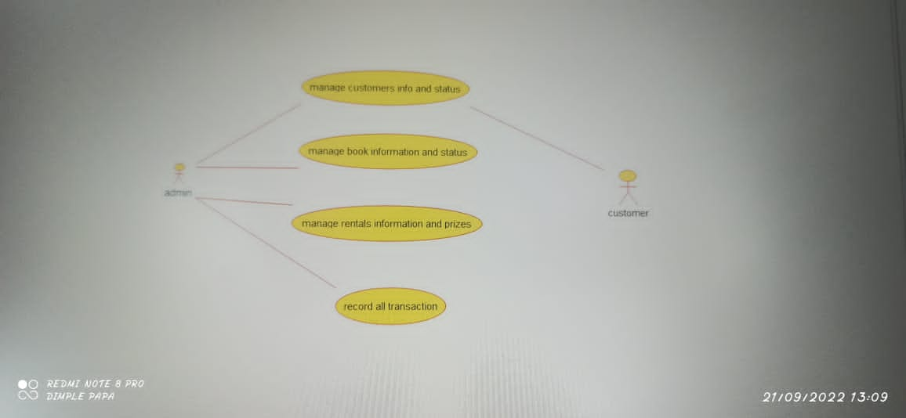

Class diagram

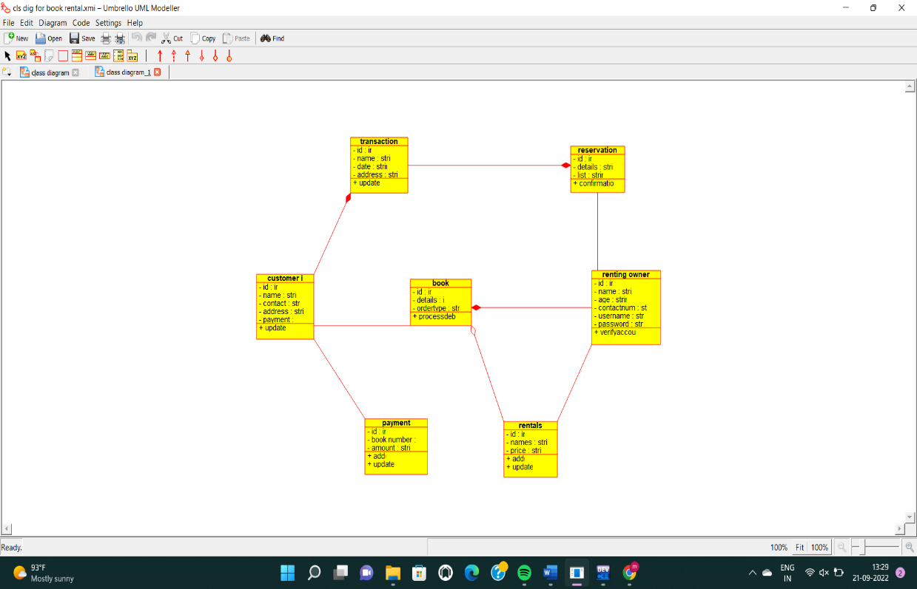

Source code

"book.h"

e#includ

// Constructors/Destructors

//

book::book () {

initAttributes();

}

book::~book () { }

//

// Methods

//

// Accessor methods

//

// Other methods

//

void book::initAttributes () {

}

3.course registration system

Use case diagram

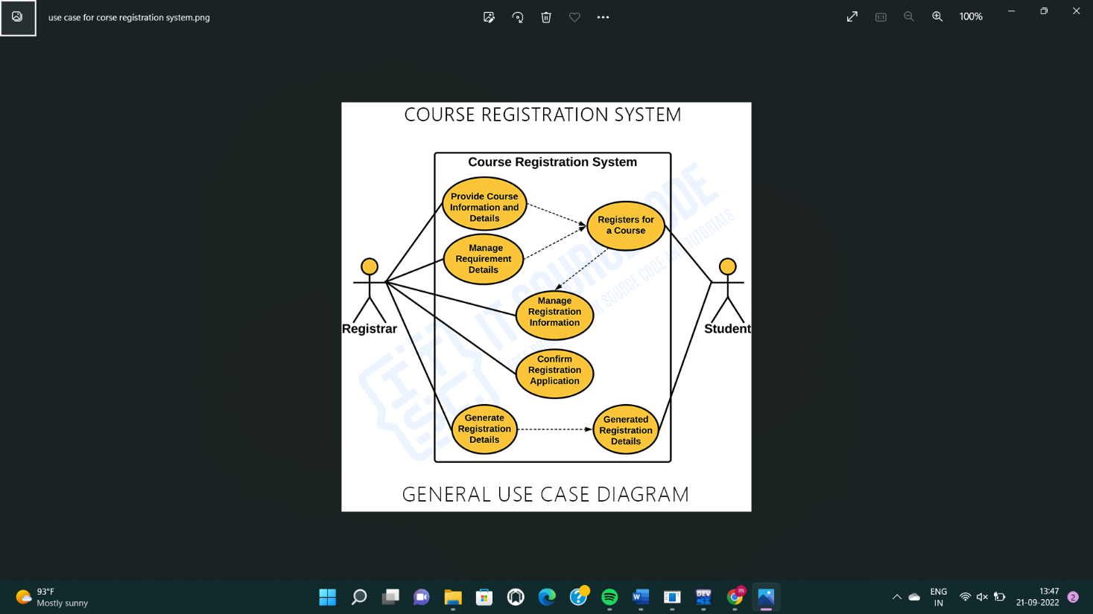

Class diagram

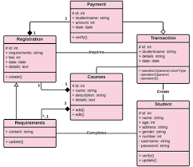

Source code

#ifndef ACCOUNT_H

#define ACCOUNT_H

#include <string>

/**

* class account

*

*/

class account

{

public:

// Constructors/Destructors

//

/**

* Empty Constructor

*/

account ();

/**

* Empty Destructor

*/

virtual ~account ();

// Static Public attributes

//

// Public attributes

//

// Public attribute accessor methods

//

// Public attribute accessor methods

//

/**

*/

void createaccount ()

{

}

/**

*/

void confirmaccount ()

{

}

protected:

// Static Protected attributes

//

// Protected attributes

//

public:

// Protected attribute accessor methods

//

protected:

public:

// Protected attribute accessor methods

//

protected:

private:

// Static Private attributes

//

// Private attributes

//

string account_id;

string type;

string student_id;

public:

// Private attribute accessor methods

//

private:

public:

// Private attribute accessor methods

//

/**

* Set the value of account_id

* @param new_var the new value of account_id

*/

void setAccount_id (string new_var) {

account_id = new_var;

}

/**

* Get the value of account_id

* @return the value of account_id

*/

string getAccount_id () {

return account_id;

}

/**

* Set the value of type

* @param new_var the new value of type

*/

void setType (string new_var) {

type = new_var;

}

/**

* Get the value of type

* @return the value of type

*/

string getType () {

return type;

}

/**

* Set the value of student_id

* @param new_var the new value of student_id

*/

void setStudent_id (string new_var) {

student_id = new_var;

}

/**

* Get the value of student_id

* @return the value of student_id

*/

string getStudent_id () {

return student_id;

}

private:

void initAttributes () ;

};

#endif // ACCOUNT_H

4.stock analysis system

Use case diagram

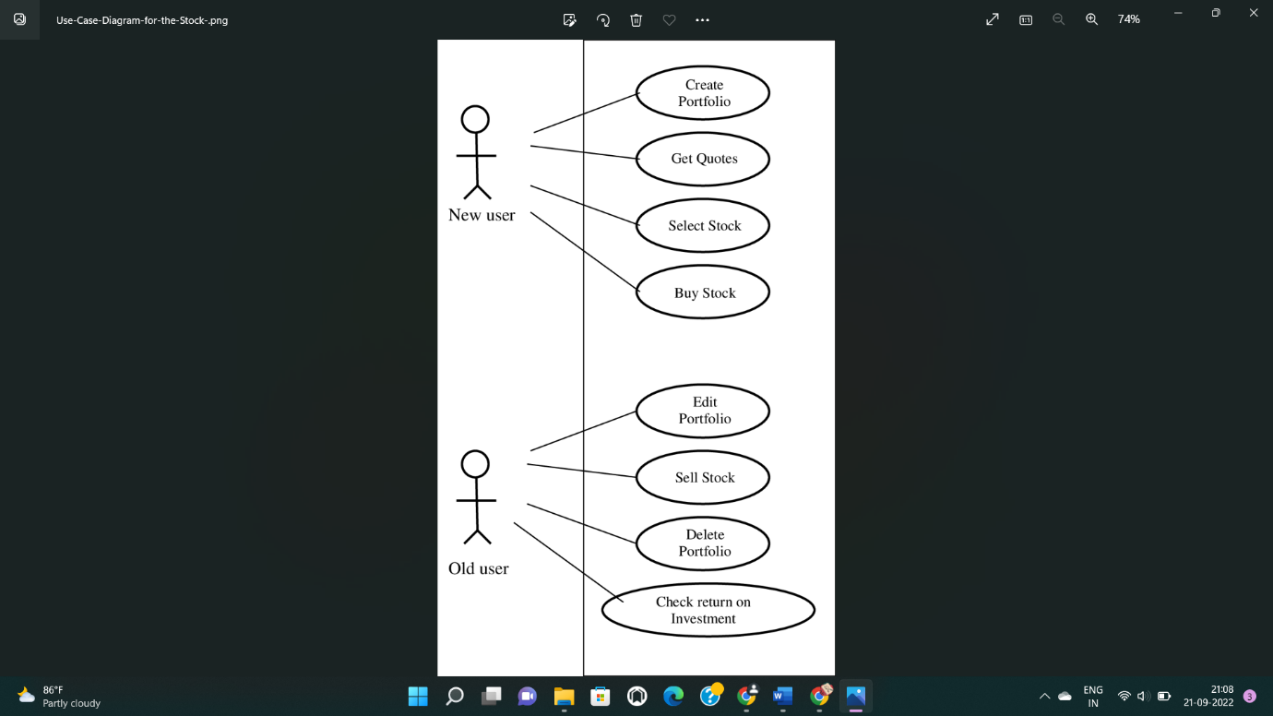

Class diagram

[9:18 pm, 21/09/2022] sneha Ooad: #include "user.h"

[9:20 pm, 21/09/2022] sneha Ooad: // Constructors/Destructors

//

user::user () {

initAttributes();

}

user::~user () { }

//

// Methods

//

// Accessor methods

//

// Other methods

//

void user::initAttributes () {

}

Stock

#include "stock.h"

// Constructors/Destructors

//

stock::stock () {

initAttributes();

}

stock::~stock () { }

//

// Methods

//

// Accessor methods

//

// Other methods

//

void stock::initAttributes () {

}

Product

#include "product.h"

// Constructors/Destructors

//

product::product () {

initAttributes();

}

product::~product () { }

//

// Methods

//

// Accessor methods

//

// Other methods

//

void product::initAttributes () {

}

Store

#include "store.h"

// Constructors/Destructors

//

store::store () {

initAttributes();

}

store::~store () { }

//

// Methods

//

// Accessor methods

//

// Other methods

//

void store::initAttributes () {

}

Bill

#include "bill.h"

// Constructors/Destructors

//

bill::bill () {

initAttributes();

}

bill::~bill () { }

//

// Methods

//

// Accessor methods

//

// Other methods

//

void bill::initAttributes () {

}

Permission

#include "permission.h"

// Constructors/Destructors

//

permission::permission () {

initAttributes();

}

permission::~permission () { }

//

// Methods

//

// Accessor methods

//

// Other methods

//

void permission::initAttributes () {

}

Customer

#include "customer.h"

// Constructors/Destructors

//

customer::customer () {

initAttributes();

}

customer::~customer () { }

//

// Methods

//

// Accessor methods

//

// Other methods

//

void customer::initAttributes () {

}

[9:20 pm, 21/09/2022] sneha Ooad: 4

[9:21 pm, 21/09/2022] sneha Ooad: SOURCE CODE:

Admin

#include "admin.h"

// Constructors/Destructors

//

admin::admin () {

initAttributes();

}

admin::~admin () { }

//

// Methods

//

// Accessor methods

//

// Other methods

//

void admin::initAttributes () {

}

Course class

#include "course_class.h"

// Constructors/Destructors

//

course_class::course_class () {

initAttributes();

}

course_class::~course_class () { }

//

// Methods

//

// Accessor methods

//

// Other methods

//

void course_class::initAttributes () {

}

Registration class

#include "registration_class.h"

// Constructors/Destructors

//

registration_class::registration_class () {

initAttributes();

}

registration_class::~registration_class () { }

//

// Methods

//

// Accessor methods

//

// Other methods

//

void registration_class::initAttributes () {

}

[9:21 pm, 21/09/2022] sneha Ooad: Staff

#include "staff.h"

// Constructors/Destructors

//

staff::staff () {

initAttributes();

}

staff::~staff () { }

//

// Methods

//

// Accessor methods

//

// Other methods

//

void staff::initAttributes () {

}

Student

#include "student.h"

// Constructors/Destructors

//

student::student () {

initAttributes();

}5

student::~student () { }

//

// Methods

//

// Accessor methods

//

// Other methods

//

void student::initAttributes () {

}

5.online course registration

Use diagram

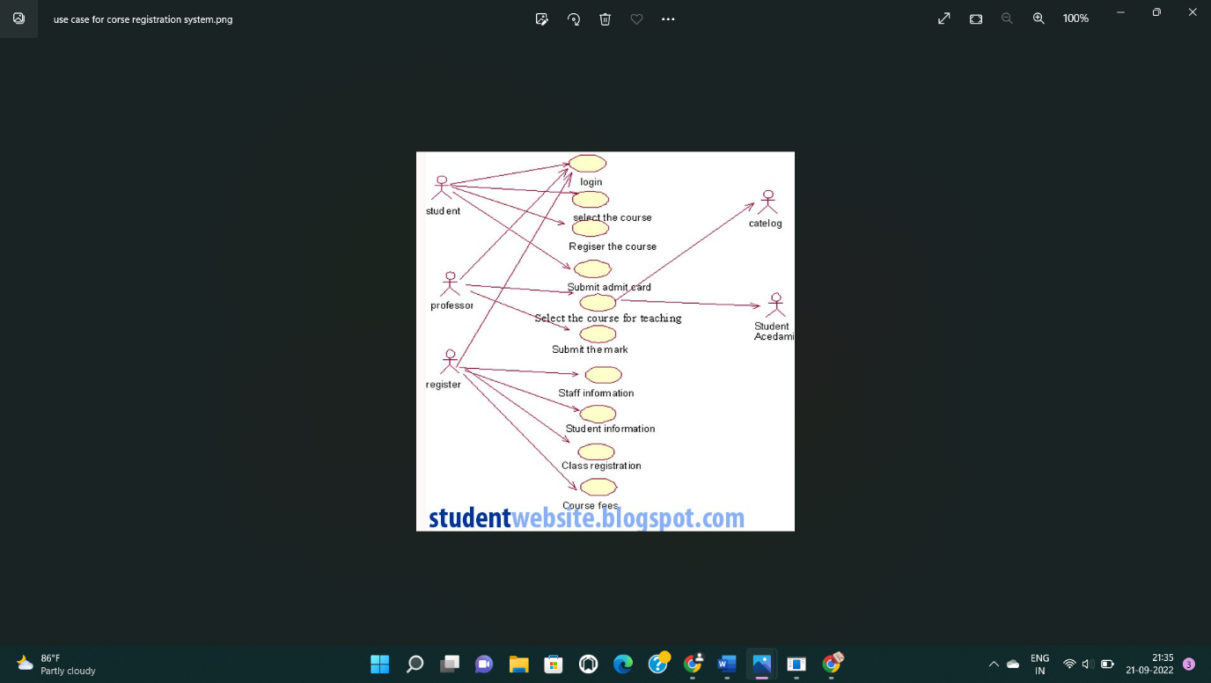

Class diagram

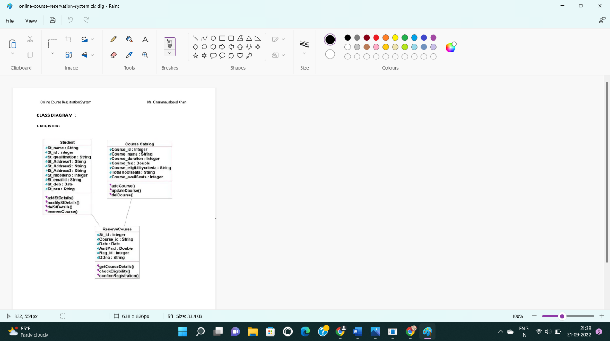

Source code

[9:21 pm, 21/09/2022] sneha Ooad: Admin

#include "admin.h"

// Constructors/Destructors

//

admin::admin () {

initAttributes();

}

admin::~admin () { }

//

// Methods

//

// Accessor methods

//

// Other methods

//

void admin::initAttributes () {

}

Course class

#include "course_class.h"

// Constructors/Destructors

//

course_class::course_class () {

initAttributes();

}

course_class::~course_class () { }

//

// Methods

//

// Accessor methods

//

// Other methods

//

void course_class::initAttributes () {

}

Registration class

#include "registration_class.h"

// Constructors/Destructors

//

registration_class::registration_class () {

initAttributes();

}

registration_class::~registration_class () { }

//

// Methods

//

// Accessor methods

//

// Other methods

//

void registration_class::initAttributes () {

}

[9:21 pm, 21/09/2022] sneha Ooad: Staff

#include "staff.h"

// Constructors/Destructors

//

staff::staff () {

initAttributes();

}

staff::~staff () { }

//

// Methods

//

// Accessor methods

//

// Other methods

//

void staff::initAttributes () {

}

Student

#include "student.h"

// Constructors/Destructors

//

student::student () {

initAttributes();

}5

student::~student () { }

//

// Methods

//

// Accessor methods

//

// Other methods

//

void student::initAttributes () {

}

6.f-ticketing

Use cse diagram

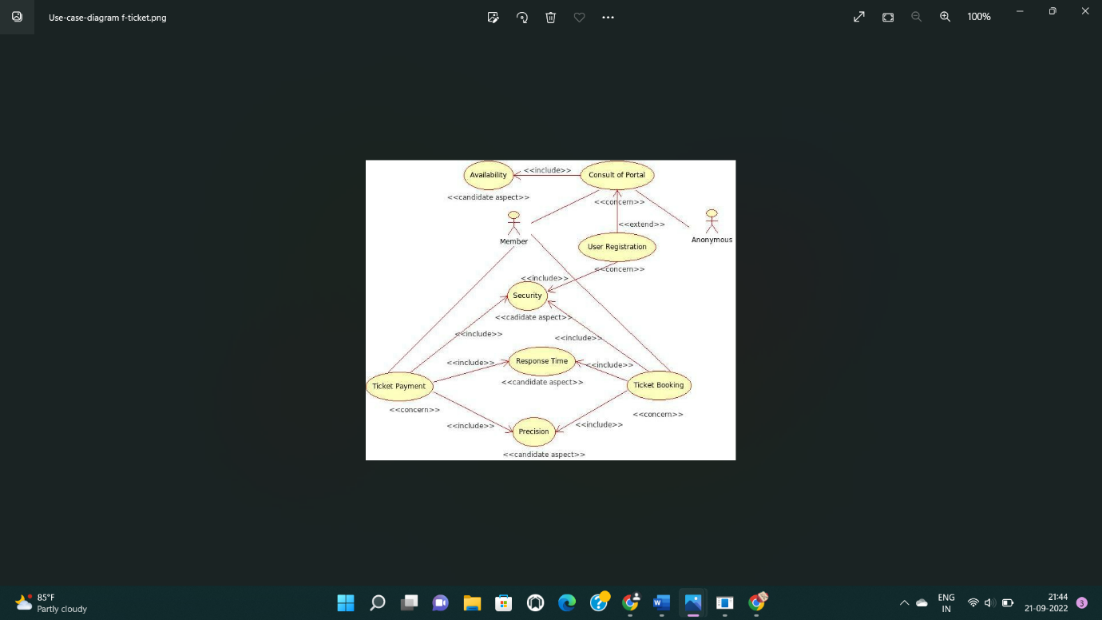

Class diagram

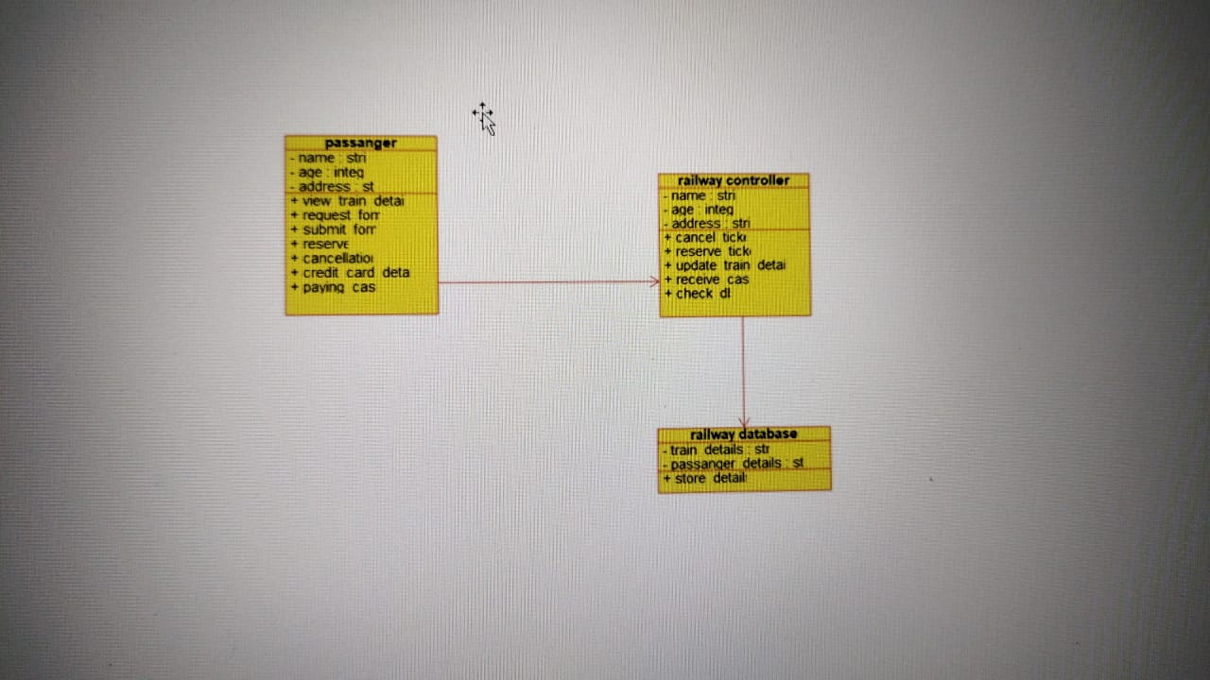

Sourse code

#ifndef INTEGER_H

#define INTEGER_H

#include <string>

/**

* class integer

*

*/

class integer

{

public:

// Constructors/Destructors

//

/**

* Empty Constructor

*/

integer ();

/**

* Empty Destructor

*/

virtual ~integer ();

// Static Public attributes

//

// Public attributes

//

// Public attribute accessor methods

//

// Public attribute accessor methods

//

protected:

// Static Protected attributes

//

// Protected attributes

//

public:

// Protected attribute accessor methods

//

protected:

public:

// Protected attribute accessor methods

//

protected:

private:

// Static Private attributes

//

// Private attributes

//

public:

// Private attribute accessor methods

//

private:

public:

// Private attribute accessor methods

//

private:

};

#endif // INTEGER_

7.credit card processing system

Use case diagram

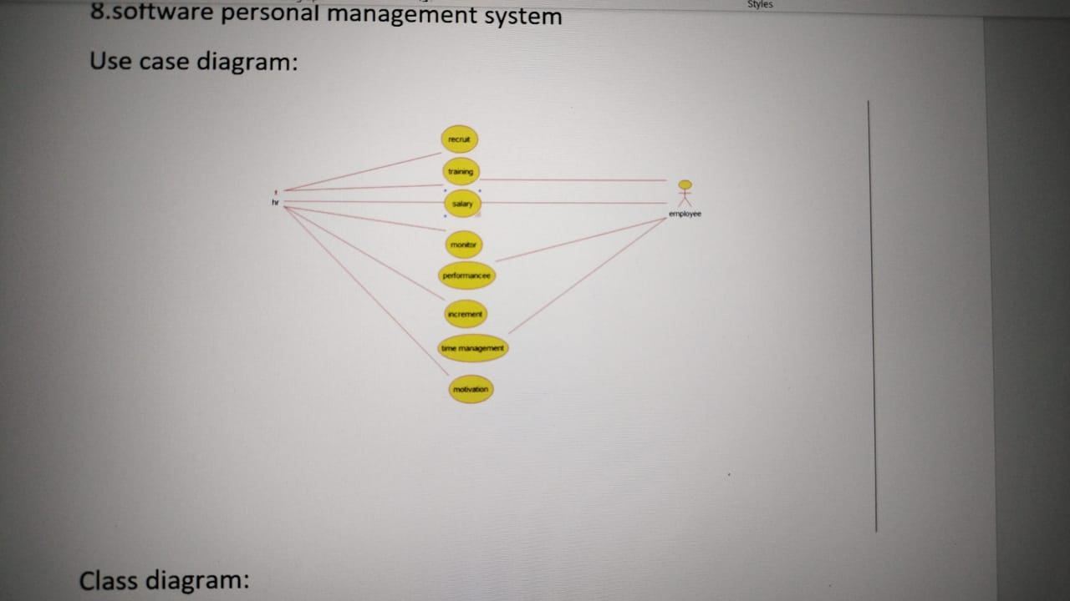

Class diagram

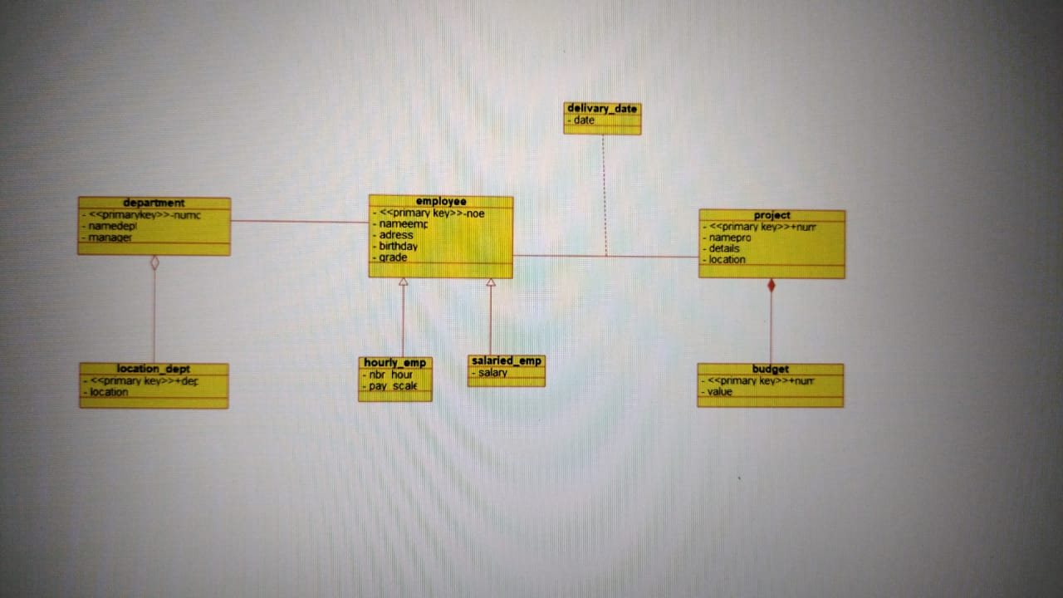

Source code

ifndef BUDGET_H

#define BUDGET_H

#include <string>

#include vector

/**

* class budget

*

*/

class budget

{

public:

// Constructors/Destructors

//

/**

* Empty Constructor

*/

budget ();

/**

* Empty Destructor

*/

virtual ~budget ();

// Static Public attributes

//

// Public attributes

//

// Public attribute accessor methods

//

// Public attribute accessor methods

//

protected:

// Static Protected attributes

//

// Protected attributes

//

public:

// Protected attribute accessor methods

//

protected:

public:

// Protected attribute accessor methods

//

protected:

private:

// Static Private attributes

//

// Private attributes

//

void _primary_key_numpro;

void value;

public:

// Private attribute accessor methods

//

private:

public:

// Private attribute accessor methods

//

/**

* Set the value of _primary_key_numpro

* @param new_var the new value of _primary_key_numpro

*/

void set_primary_key_numpro (void new_var) {

_primary_key_numpro = new_var;

}

/**

* Get the value of _primary_key_numpro

* @return the value of _primary_key_numpro

*/

void get_primary_key_numpro () {

return _primary_key_numpro;

}

/**

* Set the value of value

* @param new_var the new value of value

*/

void setValue (void new_var) {

value = new_var;

}

/**

* Get the value of value

* @return the value of value

*/

void getValue () {

return value;

}

private:

void initAttributes () ;

};

#endif // BUDGET_H

8.software management system

Use case diagram

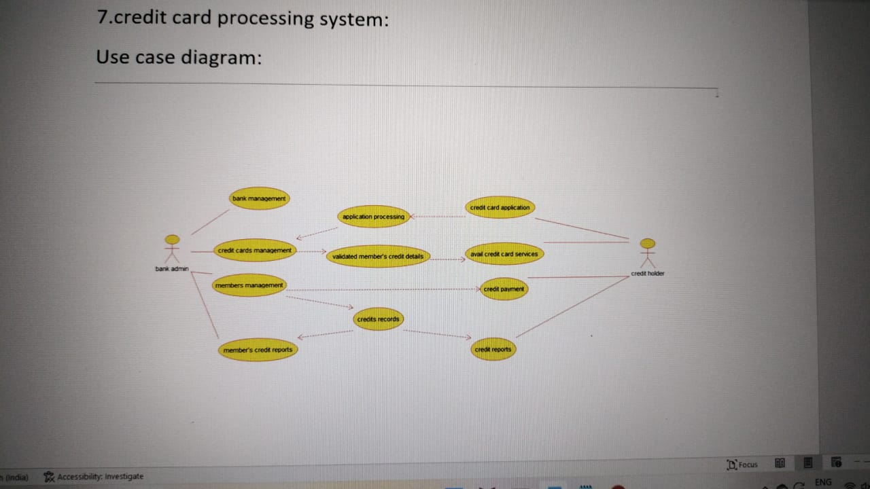

Class diagram

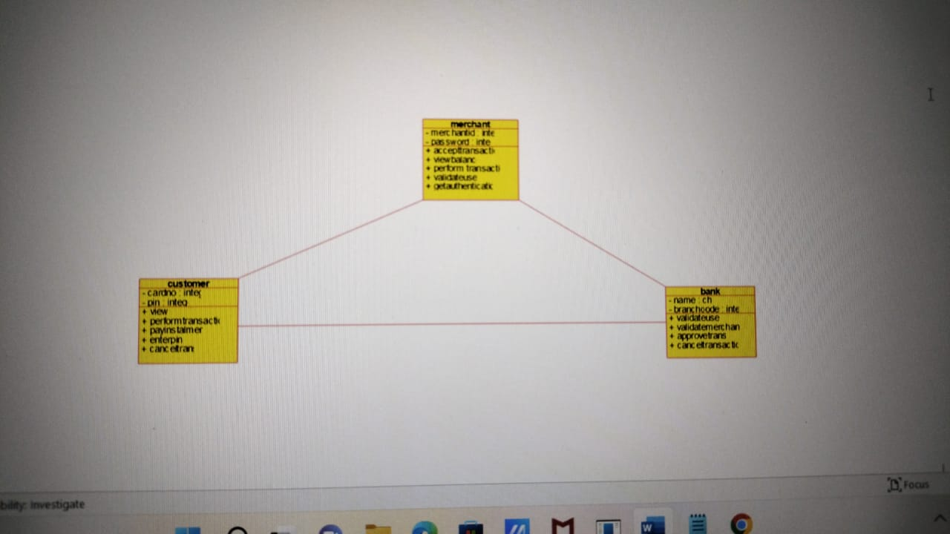

Source code

#ifndef INTEGER_H

#define INTEGER_H

#include <string>

/**

* class integer

*

*/

class integer

{

public:

// Constructors/Destructors

//

/**

* Empty Constructor

*/

integer ();

/**

* Empty Destructor

*/

virtual ~integer ();

// Static Public attributes

//

// Public attributes

//

// Public attribute accessor methods

//

// Public attribute accessor methods

//

protected:

// Static Protected attributes

//

// Protected attributes

//

public:

// Protected attribute accessor methods

//

protected:

public:

// Protected attribute accessor methods

//

protected:

private:

// Static Private attributes

//

// Private attributes

//

public:

// Private attribute accessor methods

//

private:

public:

// Private attribute accessor methods

//

private:

};

#endif // INTEGER_H

9.e book management system

Use case diagram

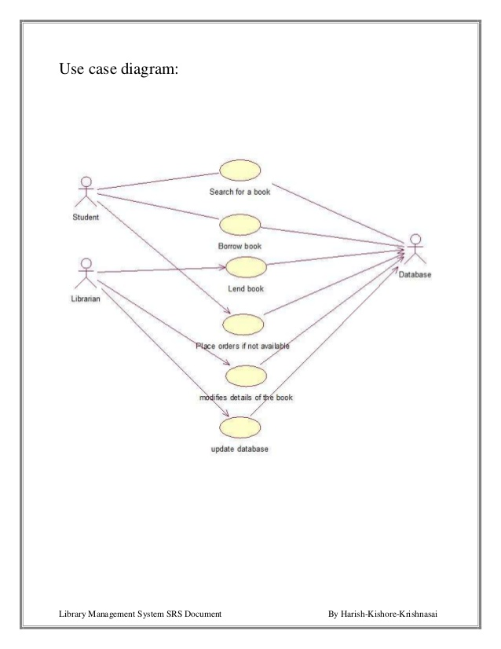

Class diagram

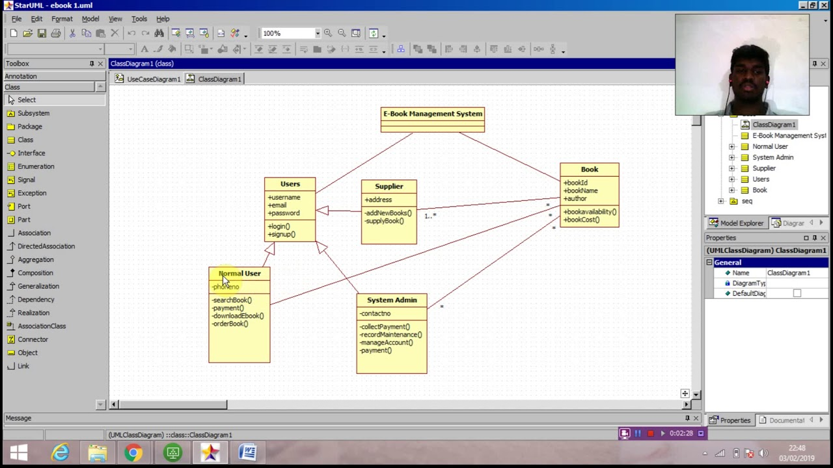

Source code

#include "administrator.h"

// Constructors/Destructors

//

administrator::administrator () {

initAttributes();

}

administrator::~administrator () { }

//

// Methods

//

// Accessor methods

//

// Other methods

//

void administrator::initAttributes () {

}

Download

#include "download.h"

// Constructors/Destructors

//

download::download () {

initAttributes();

}

download::~download () { }

//

// Methods

//

// Accessor methods

//

// Other methods

//

void download::initAttributes () {

}

Book

#include "book.h"

// Constructors/Destructors

//

book::book () {

initAttributes();

}

book::~book () { }

//

// Methods

//

// Accessor methods

//

// Other methods

//

void book::initAttributes () {

}

Registered user

#include "registered_user.h"

// Constructors/Destructors

//

registered_user::registered_user () {

initAttributes();

}

registered_user::~registered_user () { }

//

// Methods

//

// Accessor methods

//

// Other methods

//

void registered_user::initAttributes () {

}

Visitor

#include "visitor.h"

// Constructors/Destructors

//

visitor::visitor () {

initAttributes();

}

visitor::~visitor () { }

//

// Methods

//

// Accessor methods

//

// Other methods

//

void visitor::initAttributes () {

10.recruitment system

Use case digram

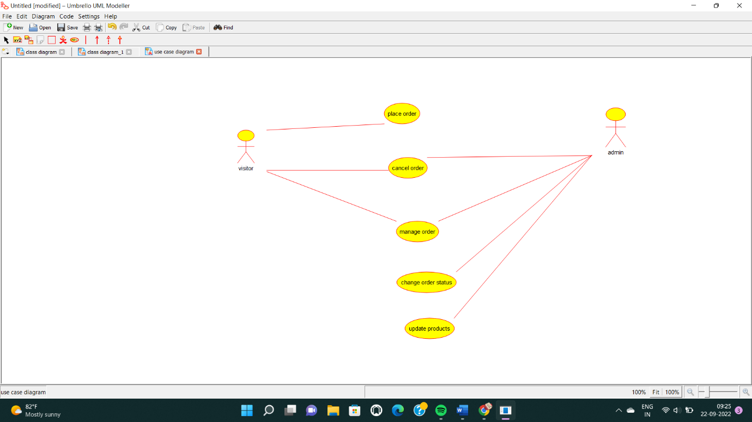

Class digram

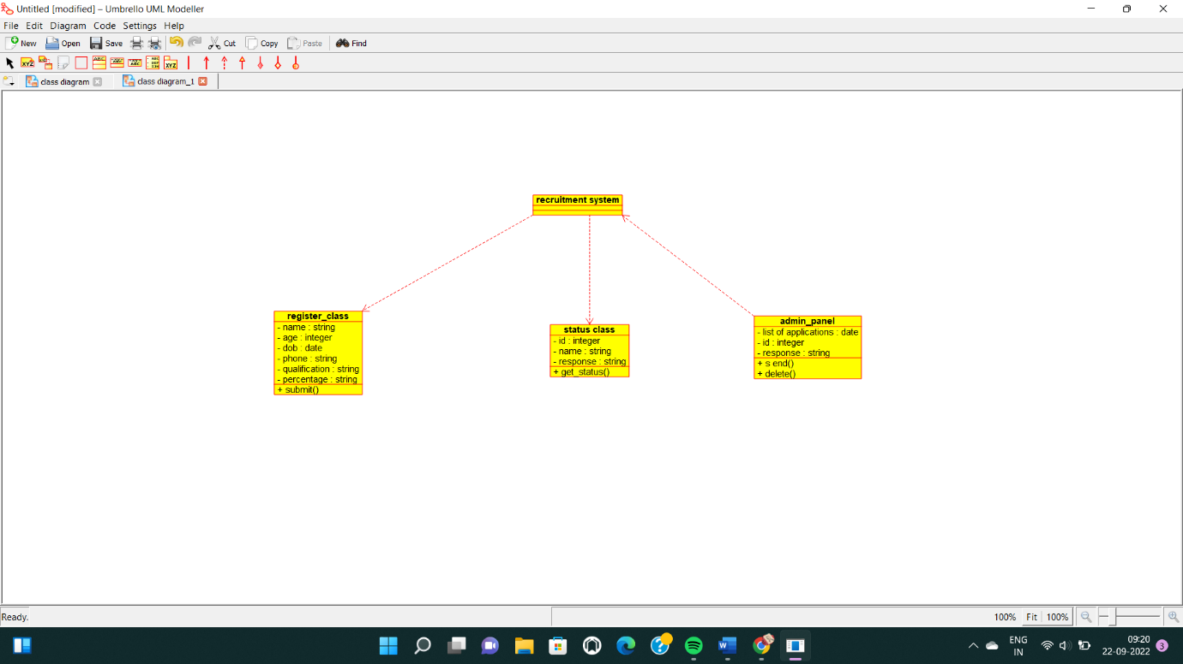

Sorure code

#include "admin_panel.h"

// Constructors/Destructors

//

admin_panel::admin_panel () {

initAttributes();

}

admin_panel::~admin_panel () { }

//

// Methods

//

// Accessor methods

//

// Other methods

//

void admin_panel::initAttributes () {

}